Nurhasan, Majdi October 17, 2019

DBMS Lab / 5:40 P – 8:40 P / Th

*Database Management System Project Documentation:*

*Journal of E-commerce Research Knowledge*

1. Business Rules

(A)

* Unsolicited manuscripts are submitted by authors.
* When a manuscript is received, the editor will assign the manuscript a number, and record some basic information about it in the system.
* The title of the manuscript, the date it was received, and a manuscript status of “received” are entered.
* Information about the author(s) is also recorded.
* For each author, the author’s name, mailing address, e-mail address, and affiliation (school or company for which the author works) are recorded.
* Every manuscript must have an author.
* Only authors who have submitted manuscripts are kept in the system.
* It is typical for a manuscript to have several authors.
* A single author may have submitted many different manuscripts to the journal.
* Additionally, when a manuscript has multiple authors, it is important to record the order in which the authors are listed in the manuscript credits.

Entities Scouted:

1. MANUSCRIPT - ManuscriptId, EditorId, IssueId, ManuscriptTitle, DateReceived, DateAccepted, ManuscriptStatus, NumberOfPagesOccupied, OrderInIssue, BeginningPageNumber
2. AUTHOR – AuthorId, Name, MailingAddress, EmailAddress, Affiliation, Username, Password
3. EDITOR – EditorId, EditorName, Username, Password
4. AUTHOR MANUSCRIPT – ManuscriptOrderId, AuthorId, ManuscriptId, AuthorOrder

(B)

* At her earliest convenience, the editor will briefly review the topic of the manuscript to ensure that the manuscript’s contents fall within the scope of the journal.
* If the content is not within the scope of the journal, the manuscript’s status is changed to “rejected” and the author is notified via e-mail.
* If the content is within the scope of the journal, then the editor selects three or more reviewers to review the manuscript.
* Reviewers work for other companies or universities and read manuscripts to ensure the scientific validity of the manuscripts.
* For each reviewer, the system records a reviewer number, name, e-mail address, affiliation, and areas of interest.
* Areas of interest are predefined areas of expertise that the reviewer has specified. An area of interest is identified by an IS code and includes a description (e.g., IS2003 is the code for “database modeling”).
* A reviewer can have many areas of interest, and an area of interest can be associated with many reviewers.
* All reviewers must specify at least one area of interest. It is unusual, but it is possible, to have an area of interest for which the journal has no reviewers.
* The editor will change the status of the manuscript to “under review” and record which reviewers the manuscript was sent to and the date on which it was sent to each reviewer.
* A reviewer will typically receive several manuscripts to review each year, although new reviewers may not have received any manuscripts yet.

Entities Scouted:

1. REVIEWER – ReviewerId, Name, EmailAddress, Affiliation, Username, Password
2. AREA OF INTEREST – AreaOfInterestId, ISCode, Description
3. REVIEWER | AREA OF INTEREST – ReviewerAreaOfInterestId, ReviewerId, AreaOfInterestId

(C)

* The reviewers will read the manuscript at their earliest convenience and provide feedback to the editor regarding the manuscript.
* The feedback from each reviewer includes rating the manuscript on a 10-point scale for appropriateness, clarity, methodology, and contribution to the field, as well as a recommendation for publication (accept or reject).
* The editor will record all of this information in the system for each review received from each reviewer and the date that the feedback was received.
* Once all the reviewers have provided their evaluation of the manuscript, the editor will decide whether or not to publish the manuscript.
* If the editor decides to publish the manuscript, the manuscript’s status is changed to “accepted,” and the date of acceptance for the manuscript is recorded. If the manuscript is not to be published, the status is changed to “rejected.”

Entities Scouted:

1. REVIEW– ReviewId, ReviewerId, ManuscriptId, DateManuscriptReceived, AppropriatenessScore, ClarityScore, MethodologyScore, ContributionScore, ReccomendationStatus, DateReviewed

(D)

* Once a manuscript has been accepted for publication, it must be scheduled.
* For each issue of the journal, the publication period (fall, winter, spring, or summer), publication year, volume, and number are recorded.
* An issue will contain many manuscripts, although the issue may be created in the system before it is known which manuscripts will go in that issue.
* An accepted manuscript appears in only one issue of the journal. Each manuscript goes through a typesetting process that formats the content (font, font size, line spacing, justification, etc.).
* Once the manuscript has been typeset, the number of pages that the manuscript will occupy is recorded in the system.
* The editor will then make decisions about which issue (each) accepted manuscript will appear in and the order of manuscripts within each issue.
* The order and the beginning page number for each manuscript must be stored in the system.
* Once the manuscript has been scheduled for an issue, the status of the manuscript is changed to “scheduled.”
* Once an issue is published, the print date for the issue is recorded, and the statuses of all the manuscripts in that issue are changed to “published.”

Entities Scouted:

1. ISSUE – IssueId, PublicationPeriod, PublicationYear, VolumeNumber, IssueNumber, PrintDate
2. EER Diagram

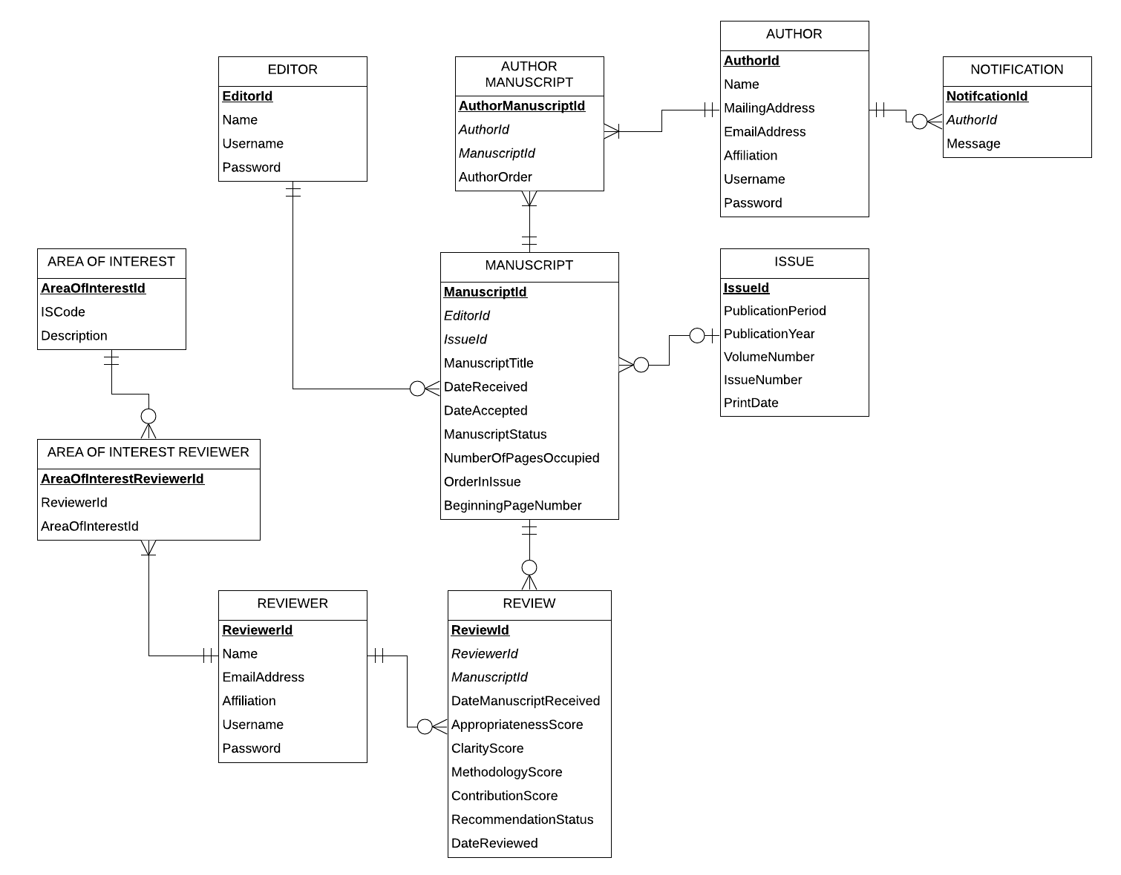

1. Relational Schema

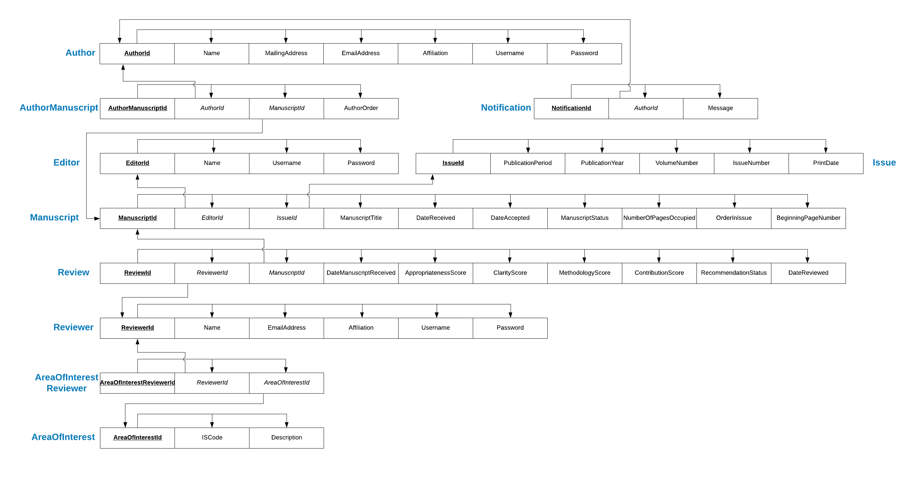

1. Assumptions
2. The editor acts as the admin of the system, therefore creation of accounts for editors may only be done through contacting directly the programmer.
3. A journal contains 20 issues then an issue contains 20 approved manuscripts.
4. Only reviewers, and authors can be added through the create account function in the program.
5. The columns *PublicationPeriod* and *ManuscriptStatus* from the entities Issue and Manuscript, respectively, will have int datatypes in order to have a much easier maintenance with the database. The following are the legend for the columns:

*PublicationPeriod:* 1 – Received, 2 – Rejected, 3 – Under Review, 4 – Accepted, 5 – Scheduled, 6 – Published

ManuscriptStatus:1 – Fall, 2 – Winter, 3 – Spring, 4 – Summer

1. Only authors who has submitted a manuscript can have manuscripts that are written by multiple authors from the same list of authors.
2. A hash method is used for making the passwords for the account secure, specifically with the SHA-256 format.